

Trunk App – Prototype Notes

25 July 2016

25 July 2016

Issued

Valid until

DATE

**www.valuelabs.com**

Deliver value to our clients by driving innovationand continually improving efficiencies

### **CONFIDENTIALITY STATEMENT**

The information contained in this document is proprietary and confidential. This document, in whole or in part, may not be copied or disseminated to any third party without the express written authorization of ValueLabs.

"Confidential Information" means any secret or proprietary information relating directly to Company's business and that of Company's affiliated companies, including but not limited to products, research programs, specific software, algorithms, computer systems, object and source codes, pricing policies, technology, employment records and policies, operational methods, marketing plans and strategies, product development techniques or plans, technical processes, designs and design projects, and other business affairs of Company and Company's affiliated companies.

The recipient must treat all Information, strictly confidential and will not, without the Company’s express written authorization, signed by one of the Company’s authorized officers, use or sell, market or disclose any Confidential Information to any third person, corporation, or association for any purpose.

**** Disclaimer

The obligation of the parties to perform the effort identified in this document is subject to the execution of a written agreement between the parties in accordance with the terms and conditions contained herein.

The information included in this proposal has been prepared and included for the purpose of this document only and shall not be construed as a precedent in any other situation outside this proposal and context.

b v

###  GENERAL INFORMATION

|  |  |
| --- | --- |
| Document Type | Our Approach – Locomote Test |
| Document Title | ValueLabs_Locomote_Test_V1 1 |
| Author | Kiran Vadlamudi |
| References | Email from Aleksandra Bugajewska |
| Associated Documentation |  |

**** Document History

|  |  |  |  |
| --- | --- | --- | --- |
| Version | Status | Reason for change | Date effective |
| 1.1 |  |  | 25 July 2016 |

###  VALUELABS CONTACT person

|  |  |
| --- | --- |
| Name | Kiran Vadlamudi |
| Designation | Project Lead |
| Phone Number | +91 40 66239630 |
| Mobile Number | +91 80889 94131 |
| E-Mail | [kiran.vadlamudi@valuelabs.com](mailto:kiran.vadlamudi@valuelabs.com) |

**** CLIENT CONTACT PERSON

|  |  |
| --- | --- |
| Name |  |
| Designation |  |
| Phone Number |  |
| Mobile Number |  |
| E-Mail |  |

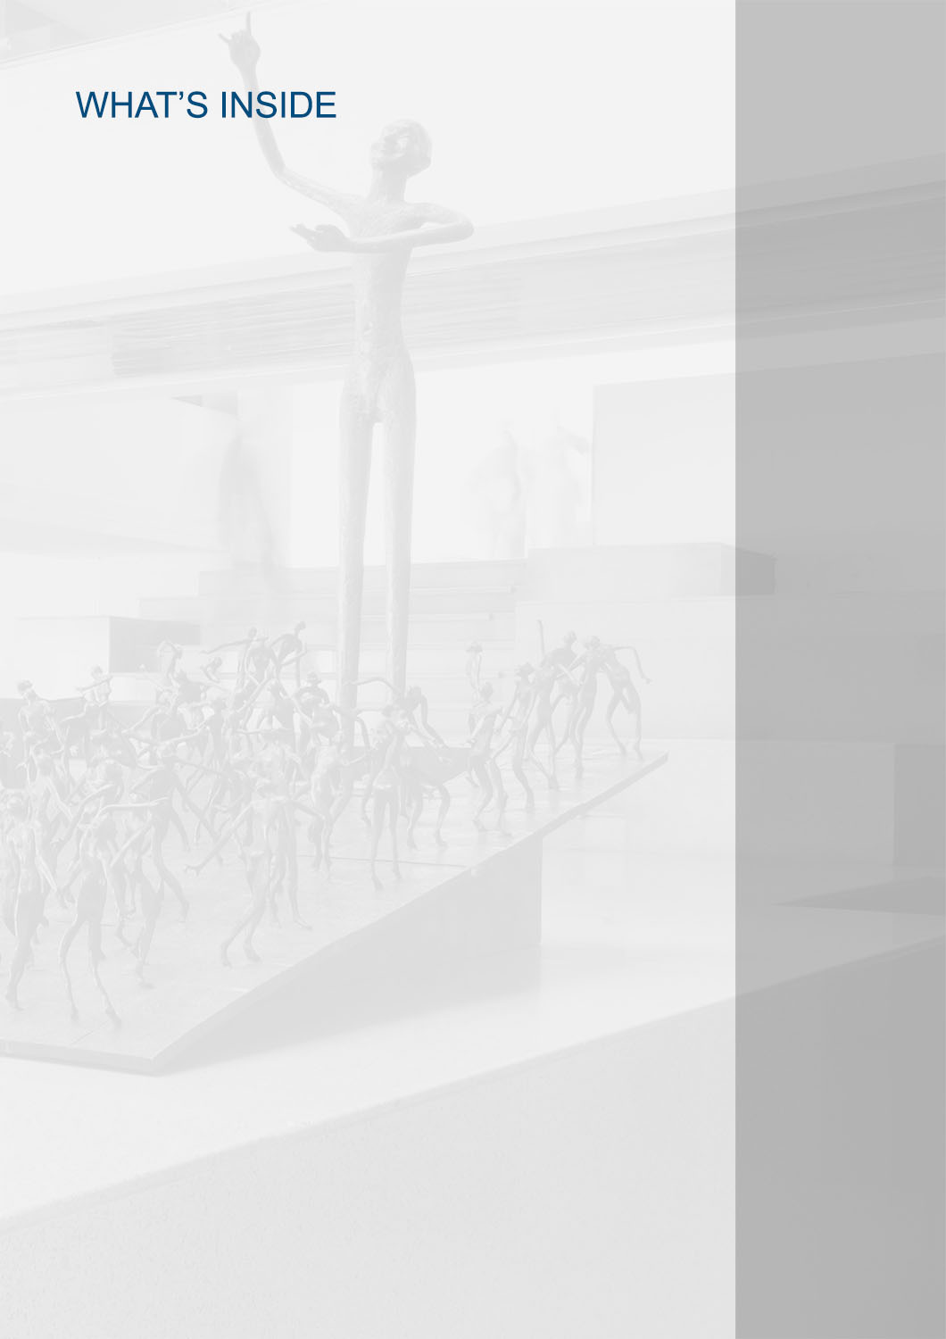

TEST APPROACH 4

# TEST APPROACH

01

###  Scope

The scope of this document is to document our approach for handling the code tests that Valuelabs was undertaking

###  OUT OF Scope

* Any functionality which is not mentioned in the requirement
* We did not focus much on UI, just used basic layout to display results
* We observed single request to third party API taking 4 seconds.
* In our application for each tab loading time is 5 seconds, performance and cache Implementation is not implemented

###  Code tests reference

<http://node.locomote.com/code-task/>

<https://gist.github.com/owenbyrne/97e6b40df7b94db8c2724bf7b0579b33>

###  OUR APPROACH - JAVASCRIPT CODING TEST

**Without using JavaScript’s bind function, implement the magic function so that:**

* + Js-challenge-1.js
  + Included both forms with fixed parameters and with all arguments.
  + Extended JavaScript Function object to add magic() function.

**Say you have a http://basketball.example.com/thisweek.json HTTP endpoint that returns the following JSON:**

* + games-results.html
  + Js-challenge-2.js, contains the logic to print the results.
  + Used static JSON files for results.
  + Added a loop to get all the games responses and collected in a Array then passed the result to display the list in required format to parseResults() function.

**Note:** Given API URLS are not working, so stored all the URLs data in static JSON files.

**Write a function that creates a deep copy of an object, without using JSON.stringify.**

* + Js-challenge-3.js
  + copyObject() function will check for the object type and create new copy for the returning object.

**Tabs**

* + page : - tabs.html
  + Tab-panel.js contains the code for the tab Panel implementation.
  + Provided capability to activate any tab on load.
  + Added extra div element to collect all the tab headers and assigned an event listener to hide and show the active tab contents.

**Flight Search API:**

We implemented three tier architecture.

* Presentation Logic - Used mustache framework, jQuery for ajax requests, loadash , moment frameworks used for date and
* Business Logic – Used Express node Framework
* Application Logic - Used node request module to get third party API data

###  Time TAKEN

**JavaScript Coding Task:**

* Understanding the requirements – 1 hour
* Unit testing the Application – 1 hour
* Development: 8 hours
* Documentation – 1 hour

**Flight Search API Task:**

* Understanding the requirements – 1 hour
* Unit testing the Application – 8 hours
* Development: 32 hours
* Documentation **-** 1 Hour

###  GIT Reference

The application is available at the following location.

**FLIGHT SEARCH API:**

<https://github.com/vnvsaikiran/node_locomotive.git>

**JAVASCRIPT CODING TEST:**

<https://github.com/vnvsaikiran/node_locomotive/tree/master/JavaScript_coding_test>

###  Installing the application

Step 1: Please open start.sh file in command prompt, it will install node dependency modules and start the server at port 3000

Step 2: You can access the site from the following URL after performing step 1. http://localhost:3000

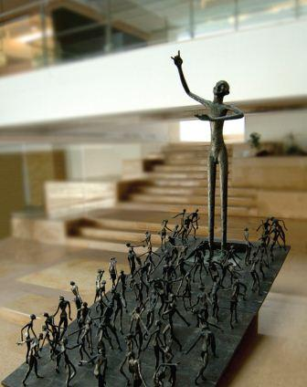

**The Ramp**

The person standing tall at the top of the ramp stands for perfection. All of us are like the different figures on the ramp, aspiring to this state of perfection, not just in our professional lives but our personal lives too. Every time we pass by the sculpture, we hopefully will be reminded that our goal is to attain perfection in everything we do, from the minutest task we do on any given day, to what we expect to make of ourselves as individuals and professionals

